SYMBIOSIS INSTITUTE OF TECHNOLOGY

*C++ AND DATA STRUCTURES*

TOPIC : Steps to install VS code

NAME : Sara Kanyal

CLASS : ENTC-B

PRN : 23070123115

1. Click on the link given below and click on download for windows. <https://code.visualstudio.com>

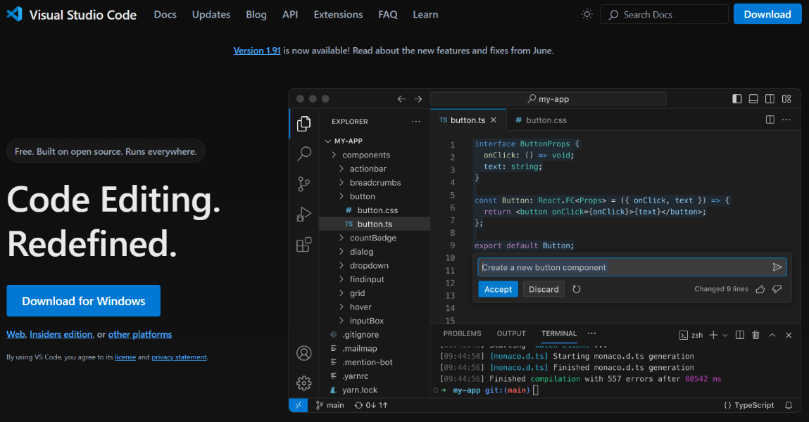

1. Check recent download history and click on installed vs code

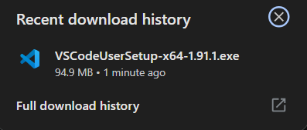

1. A pop-up will appear, accept the agreement and click next.

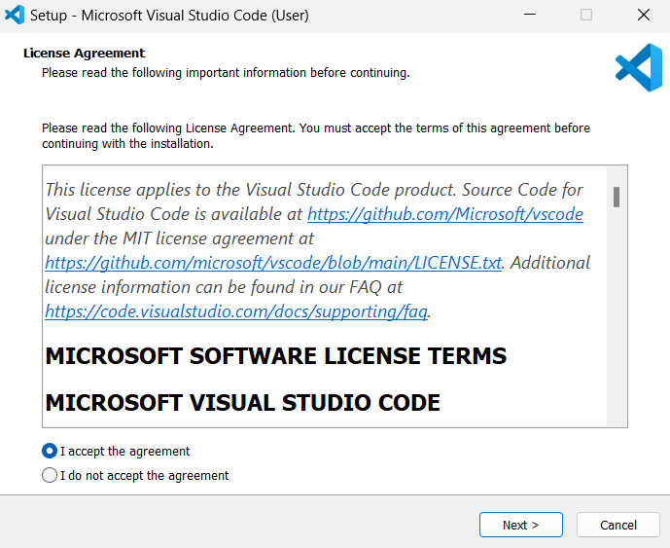

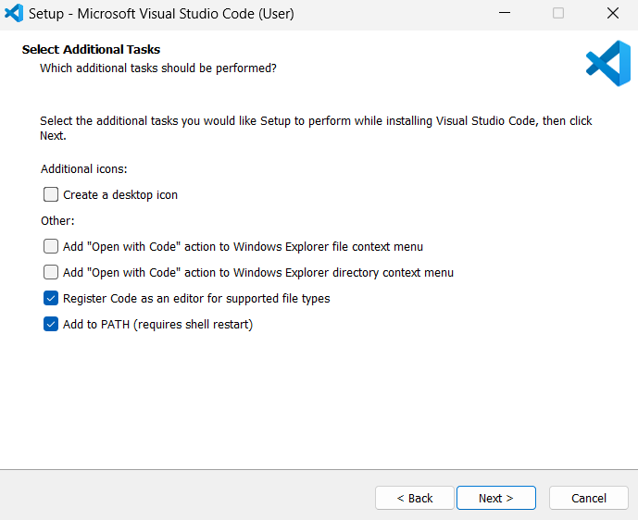

1. Click install and then finish.

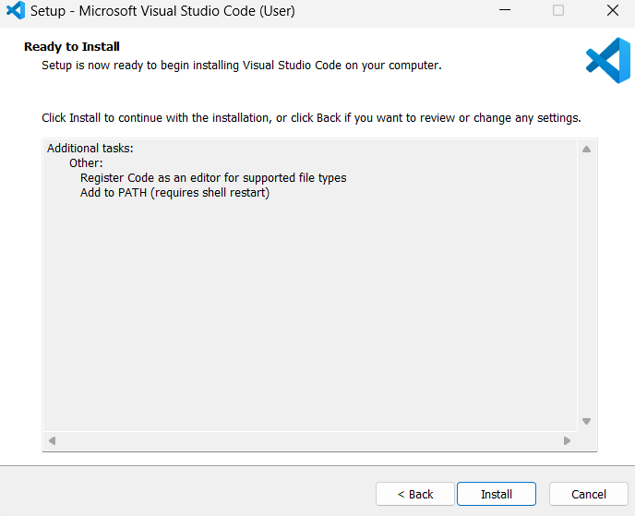

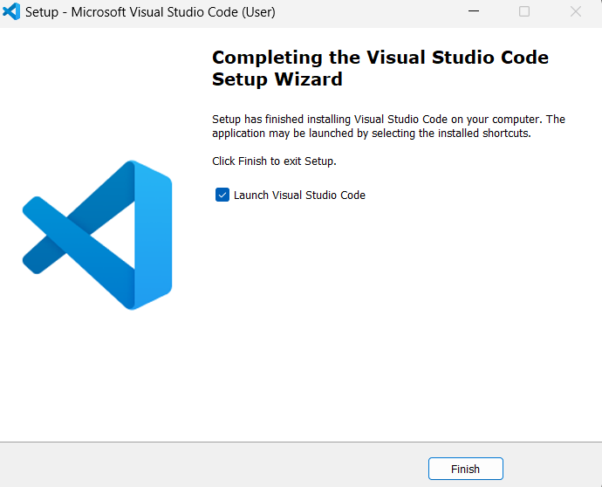

1. As your vs code is installed add extension to it, in order to run the code in C++ or c language (for e.g. coderunner)

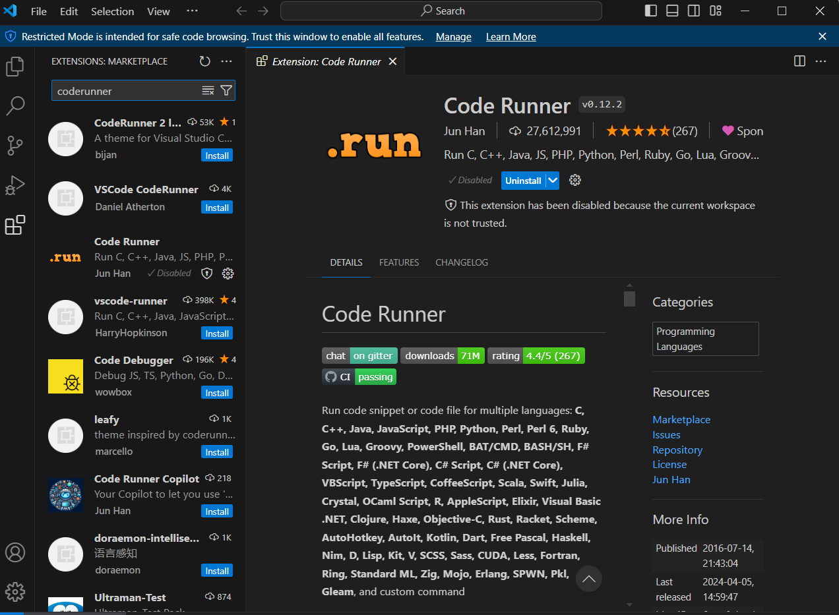

1. Search for mingw download and install it.

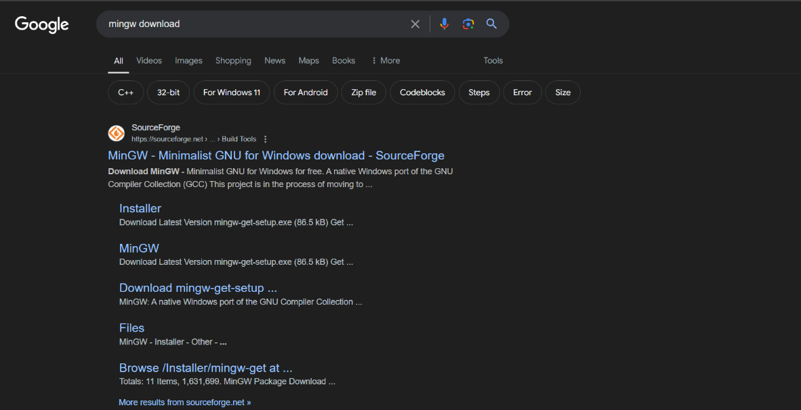

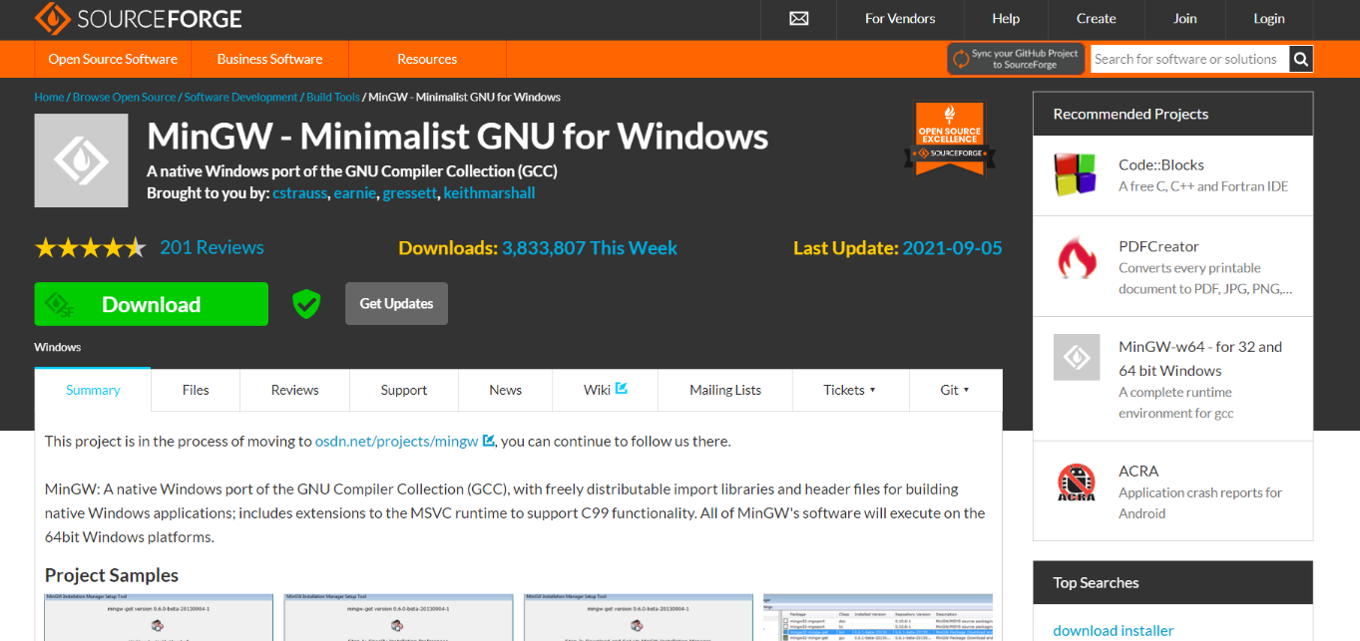

1. Click on recently installed mingw and the following pop-up will appear, click install and continue.

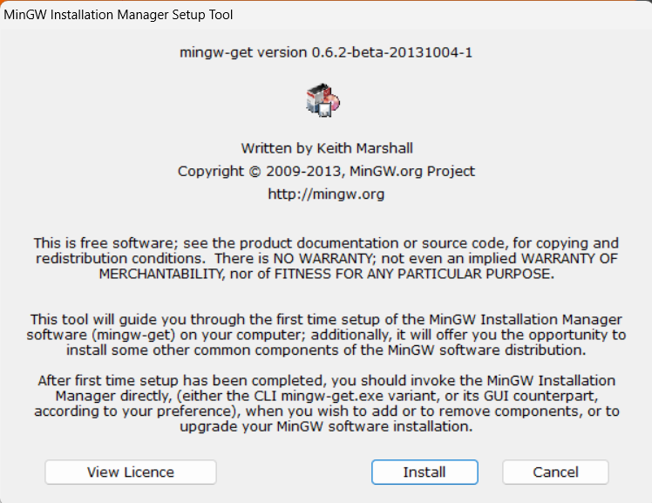

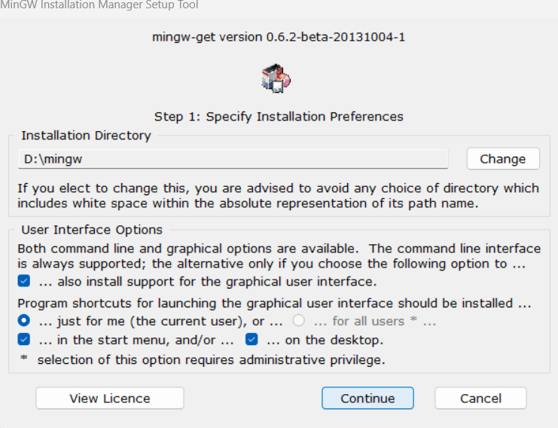

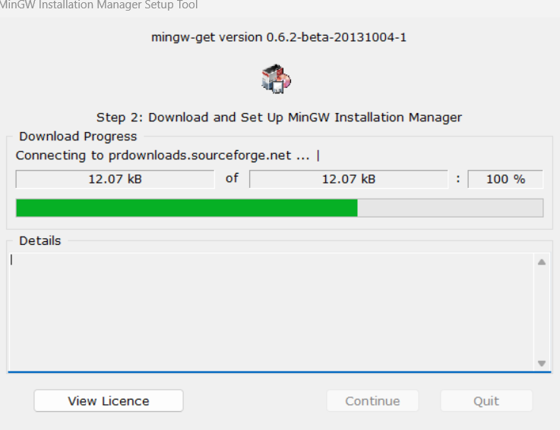

1. Select all the blocks and click on apply changes, then apply.

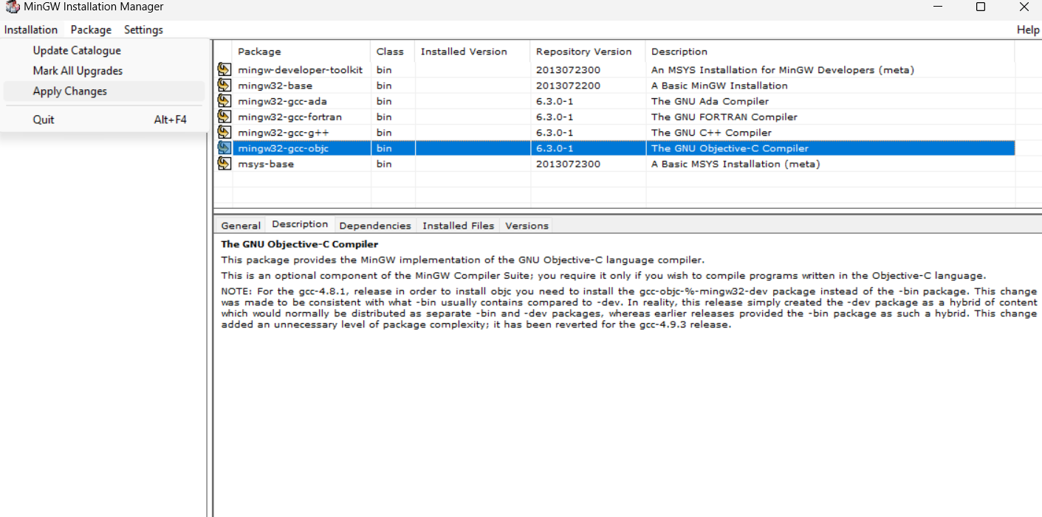

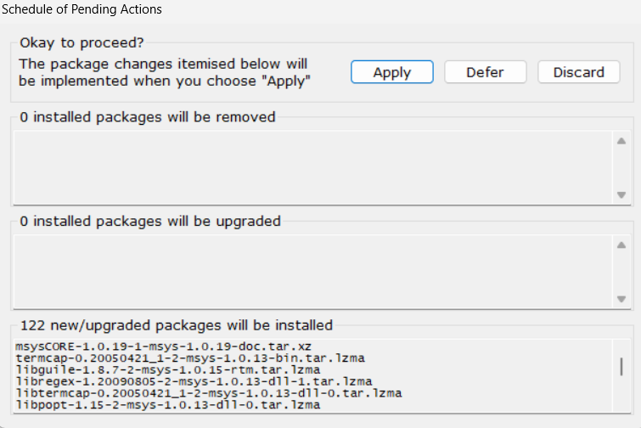

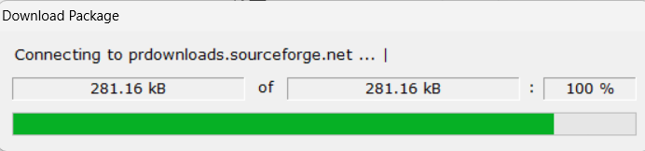

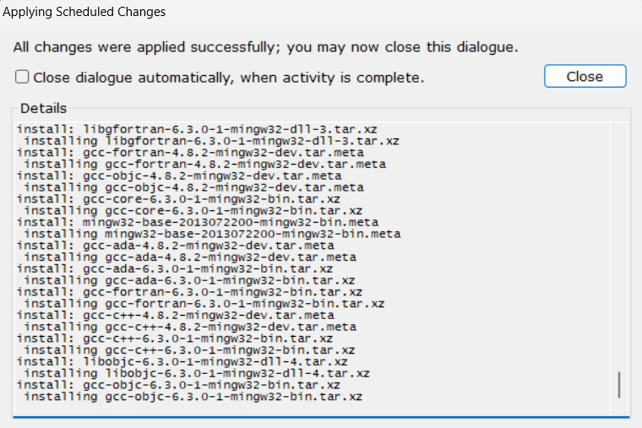

1. Right click on my pc and click on properties and then select advanced setting systems.



1. Click on Environment Variables and under system variables select path and click on edit.

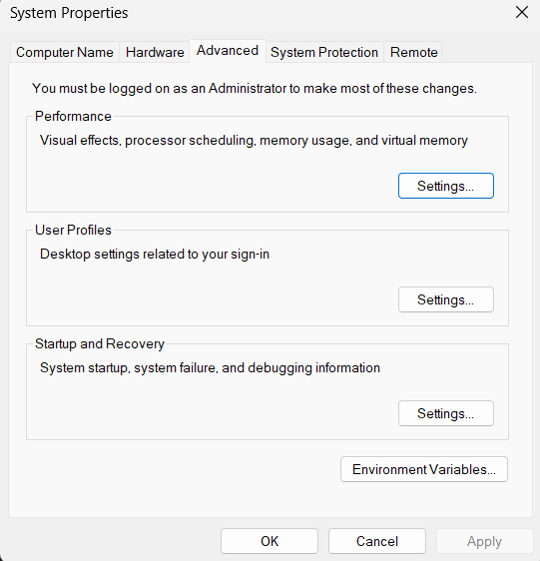

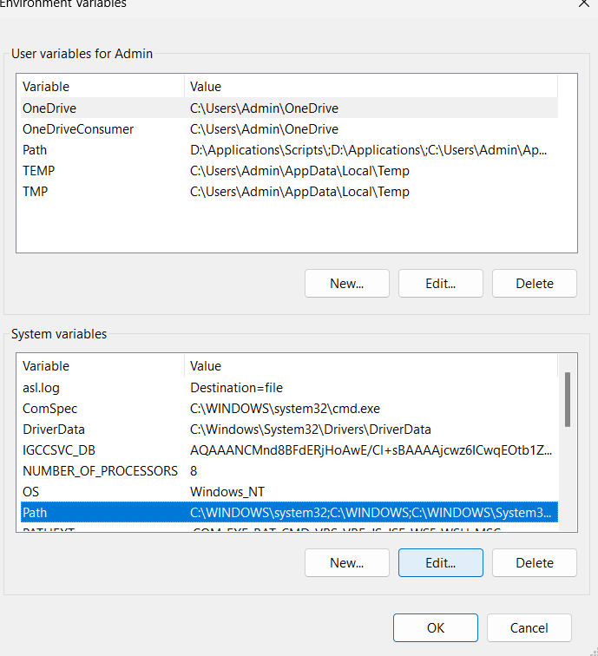

1. Click on new and copy the path of migw bin in here, click ok.

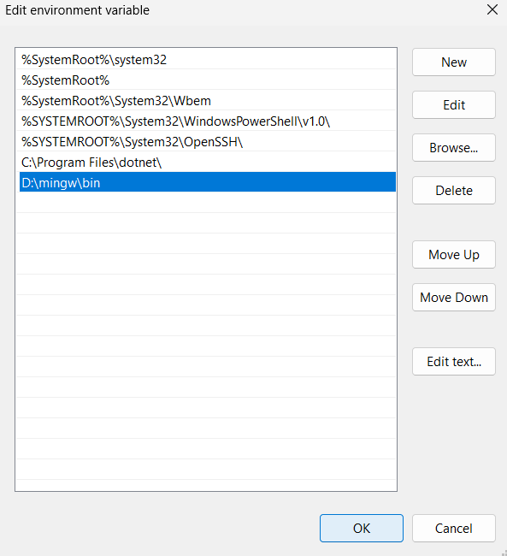

1. Your VS Code is all set up.

**EXPERIMENT 1A: Write a C++ program to print HELLO WORLD**.

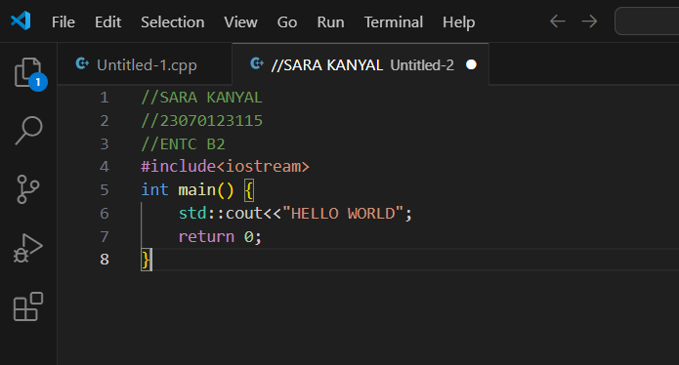

OUTPUT:

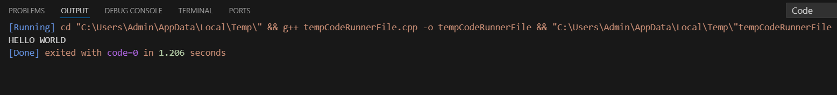

**EXPERIMENT 1B: Write a C++ program to print the sum of two numbers.**

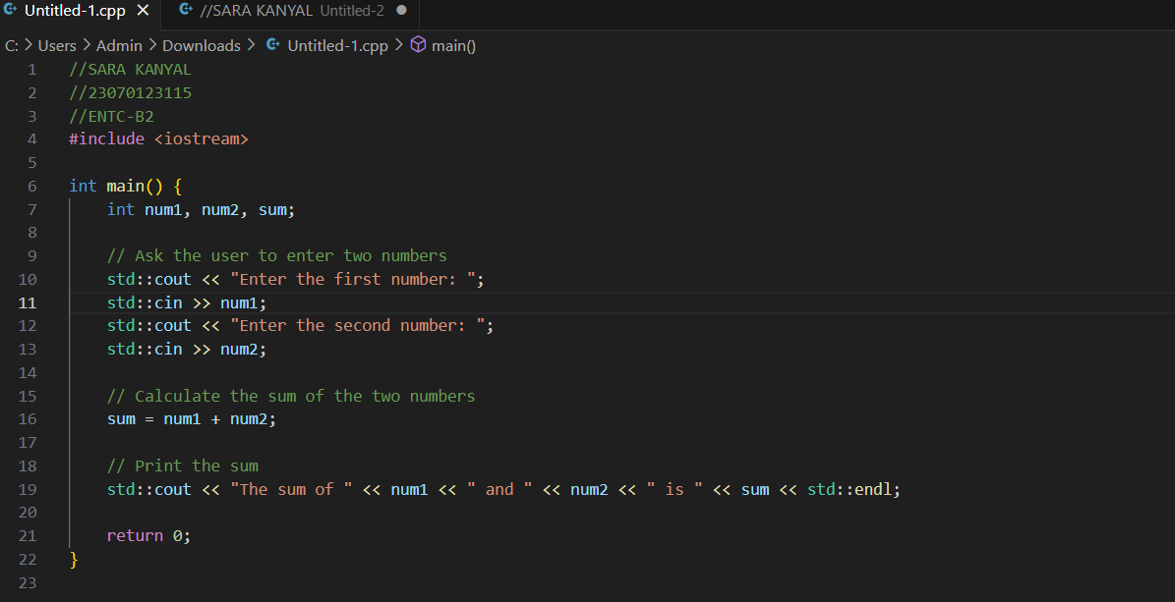

**OUTPUT:**

